**CS306 PROJECT STEP 2**

Ege Öngül

Elif Ilgın Arat

STEP 1:

For our final step of our project, we started to build our support system with real-time chat page between admins of the webpage and users of guests. To implement this, we used basic firebase server management, php to send that servers information to the webpage and some html/css to beautify our page.tablo içeren bir resim

Açıklama otomatik olarak oluşturuldu

Through the Live Help? button on the top right of the page, users can reach the chat page which look like the following.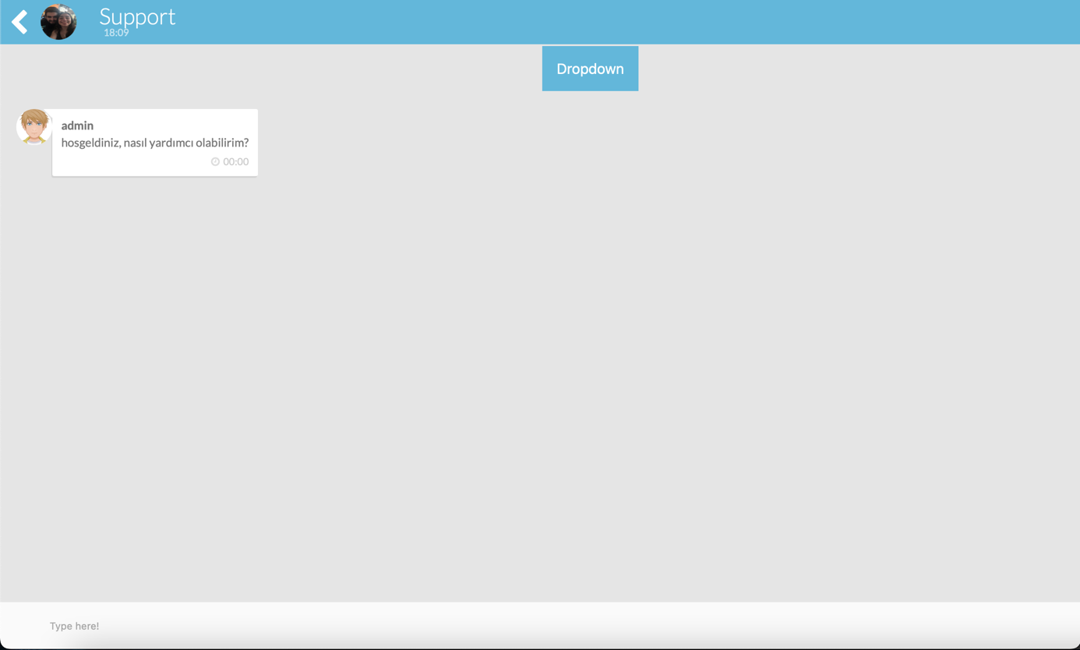

STEP 2:

There is always a message from admin to user/guest that, how can I help? And after that, conversation begins. User might ask, how can I sign up and admin will answer accordingly.

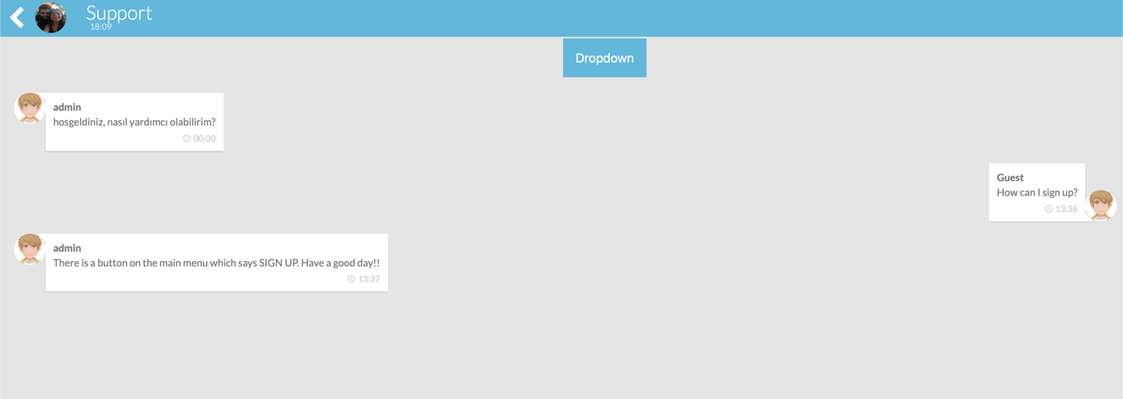

And when the conversation is finished, user can go back to main menu, forgot my password menu or suggestions menu with the dropdown menu.

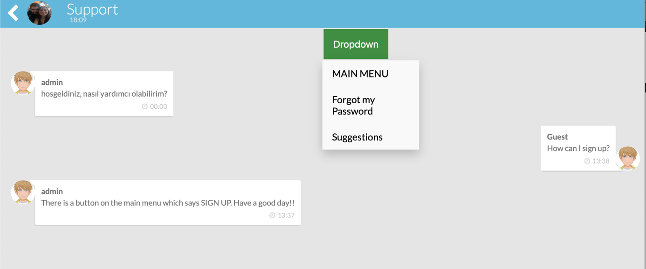

In ForgotMyPassword menu, there will be admins for registration and password changing or recovering and in the suggestions menu, there will be admins that take suggestions from the users to beautify the webpage even more!

metin içeren bir resim

Açıklama otomatik olarak oluşturuldu

